Mutual Fund

- Mutual Fund:
A Mutual Fund is a trust that pools together the savings of a number of investors who share a common financial goal. The money collected is then invested in capital market instruments such as shares, debentures and other securities based on their objective. The income earned through these investments and the capital appreciation realized are shared by its unit holders in proportion to the number of units owned by the investors.
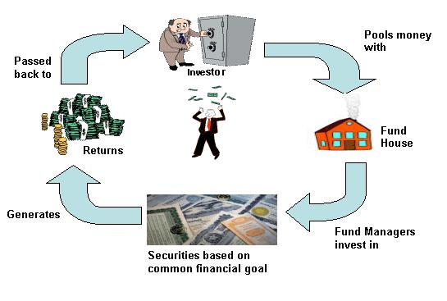

What are the advantages of mutual fund?

- Flexibility -Mutual funds offer a variety of schemes that will suit your needs over a lifetime. When you enter a new stage in your life, all you need to do is sit down with your financial advisor who will help you to rearrange your portfolio to suit your altered lifestyle..
Affordability –As a small investor, you may find that it is not possible to buy shares of larger corporations. Mutual funds generally buy and sell securities in large volumes which allow investors to benefit from lower trading costs. The smallest investor can get started

on mutual funds because of the minimal investment requirements. You can invest
with a minimum of Rs.500 in a Systematic Investment Plan on a regular basis.

- Liquidity - In open-ended schemes, you have the option of withdrawing or redeeming your money at any point of time at the current NAV

- Diversification –Risk is lowered with Mutual Fund as they invest across different industries&stocks.

- Professional Management – Qualified professionals manage your money, but they are not alone. They have a research team that continuously analyses the performance and prospects of companies. They also select suitable investments to achieve the objectives of the scheme. It is a continuous process that takes time and expertise which will add value to your investment. Fund managers are in a better position to manage your investments and get higher returns

- Low Costs – The economy of scale result in low cost.
- Regulations – All mutual funds are required to register with SEBI (Securities Exchange Board of India). They are obliged to follow strict regulations designed to protect investors. All operations are also regularly monitored by the SEBI.

- Transparency – The performance of a mutual fund is reviewed by various publications and rating agencies, making it easy for investors to compare fund to another. As a unitholder, you are provided with regular updates, for example daily NAVs, as well as information on the fund's holdings and the fund manager's strategy.

We can invest Mutual Fund in two ways-

- LUMPSUM – One time investment

What is Lump Sum

Definition: A lump sum amount is defined as a single complete sum of money. A lump sum investment is of the entire amount at one go.

For example, if an investor is willing to invest the entire amount available with him in a mutual fund, it will refer to as lump sum mutual fund investment.

Description: Lump sum investment is considered as one way of investing into mutual funds. The other method being that of systematic investment plan, popularly known as SIP. Usually lump sum investments are undertaken by big players and investors, in stocks especially those related to assets that are likely to appreciate in the long term, making the investment profitable except in cases of high volatility.

- SIP – Systematic Investment Plan

Systematic Investment Plan

What is Systematic Investment Plan (SIP)?

A Systematic Investment Plan (SIP) is a simple method of investing, used across the world as a means to accumulate wealth. It works the same way as a recurring deposit account. SIP involves investing a fixed sum of money in a specific investment scheme, on a regular basis, for a pre-determined number of periods.

What are the advantages of investing in SIP?

Helps you to invest disposable funds each month. Gives you the benefits of rupee-cost averaging
Relieves you of trying to time the market Helps you to reach your financial goals

How do I apply for SIP?

Fill up a single SIP form, and a single application form. Draw post-dated cheques (minimum 5 cheques).

Per cheque minimum SIP amount, there are many funds that have their minimum amount as low as can be as low as Rs 500/-

Auto Debit Facility

Are there any minimum amount limits for subsequent purchase in same scheme?

Yes, there is a minimum amount limits for subsequent purchase in same scheme.

Transactions types of Mutual Fund

- What is a Switch?

Some Mutual Funds provide investor with an option to shift his investment from one scheme to another within that fund this option is known as switching.

Investors can opt to switch units between Dividend Plan and Growth Plan at NAV based prices. Switching is also allowed into/from open-ended schemes currently within the Fund family or schemes that may be launched in the future at NAV based prices.

While switching between Debt and Equity Schemes, one has to take care of exit and entry loads. Switching from a Debt Scheme to Equity scheme involves an entry load while the vice versa does not involve an entry load.

Switches are subject to loads depending upon the Scheme details

- SWP :

What is Systematic Withdrawal Plan (SWP)

The unit holder may set up a Systematic Withdrawal Plan on a monthly, quarterly or semi-annual or annual basis to redeem a fixed number of units. They have to pay capital gain tax, which may be short term or long term. Any Unit holder can avail of this facility subject
to the terms and conditions contained in the application form / Offer Document, it may also include exit loads if applicable

- STP:

STP refers to Systematic Transfer Plan where in an investor invests a lump sum amount in one scheme and regularly transfers (i.e. switches) a pre-defined amount into another scheme. Every month on a specified date an amount you choose is transferred from one mutual fund scheme to another of your choice.

- Redemption:

When and how can I redeem my investments?

In an open ended fund investments can be redeemed any time but in the close ended fund investments can be redeemed only after the expiry of the lock-in period, either by submitting a physical request to any of the Karvy/CAMS SERVICE CENTREs / concerned AMC or requesting the same through the on-line services available under Investors section at the CAMS website.

Within how much time I will receive my redemption request?

A mutual fund is required to dispatch to the unit holders the dividend warrants within 30 days of the declaration of the dividend and the redemption or repurchase proceeds within 10 working days from the date of redemption or repurchase request made by the unitholder.

In case of failures to dispatch the redemption/repurchase proceeds within the stipulated time period, Asset Management Company is liable to pay interest as specified by SEBI from time to time (15% at present).

What is the Repurchase or Back End Load?

It is the charge collected by the scheme when it buys back the units from the unit holders.

.

I have not received my redemption proceeds? What should I do?

You can write / email to any of the Karvy/CAMS SERVICE CENTREs or to the AMC concerned addressing the same for further course of action.

- What are the different types of fund:
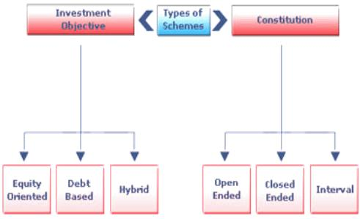

- What are open-ended funds?

An open-end fund is one that is available for subscription all through the year and is not listed on the stock exchanges. The majority of mutual funds are open-end funds. Investors have the flexibility to buy or sell any part of their investment at any time at a price linked to the fund's Net Asset Value.

- What are close-ended funds?

A closed-end fund has a fixed number of shares outstanding and operates for a fixed duration (generally ranging from 3 to 15 years). The fund would be open for subscription only during a specified period and there is an even balance of buyers and sellers, so someone would have to be selling in order for you to be able to buy it. Closed-end funds are also listed on the stock exchange so it is traded just like other stocks on an exchange or over the counter. Usually the redemption is also specified which means that they terminate on specified dates when the investors can redeem their units.

- What are interval funds?

These schemes combine the features of open-ended and closed-ended schemes. They may be traded on the stock exchange or may be open for sale or redemption during pre-determined intervals at NAV based prices.

- INVESTMENT OBJECTIVES / OPTIONS:

- EQUITY – A stock fund, or equity fund, is a fund that invests in stocks, also called equity securities. Stock funds can be contrasted with bond funds and money funds. Fund assets are typically mainly in stock, with some amount of cash, which is generally quite small, as opposed to bonds, notes, or other securities.

- Large Cap - Definition of 'Large Cap Funds' Definition: There are a plethora of mutual funds available in the market. Funds which invest a larger proportion of their corpus in companies with large market capitalization are called large cap funds

Schemes Examples – Aditya Birla Sun Life Frontline Equity Fund

- ICICI Prudential Bluechip Fund

- Invesco India Largecap Fund

- Mid Cap - A mid-cap fund is a type of investment fund that focuses its investments on companies with a capitalization in the middle range of stocks in the investable market. Companies with market capitalizations ranging from $2 billion to $10 billion are typically considered mid-cap companies.

- Schemes Examples-Franklin India Frima Fund

- Invesco India Mid Cap Fund

- Small Cap - Small cap is a term used to classify companies with a

relatively small market capitalization. ... The definition of small cap can vary among
brokerages, but it is generally a company with a market capitalization of between $300
million and $2 billion.
Schemes Examples –

- L& T Emerging Businesses Fund

- Reliance Small Cap Fund

- Multicap Fund - Definition of 'Multicap Funds' Definition: These are diversified mutual funds which can invest in stocks across market capitalization. In other words, they are market capitalization agnostic. ... That is, their portfolio comprises of large cap, midcap and small cap stocks.

- What is Balanced Fund?

The aim of balanced funds is to provide both growth and regular income as such schemes invest both in equities and fixed income securities in the proportion indicated in their offer documents. These are appropriate for investors looking for moderate growth. They generally invest 40-60% in equity and debt instruments. These funds are also affected because of fluctuations in share prices in the stock markets. However, NAVs of such funds are likely to be less volatile compared to pure equity funds

- What is diversified Fund ?

A diversified fund is a fund that is broadly diversified across multiple market sectors or geographic regions. It holds multiple securities, often in multiple asset classes. Its broad market diversification helps to prevent idiosyncratic events in one area from affecting an entire portfolio.

A diversified fund contrasts with specialized or focused funds, such as sector funds, which focus on stocks in specific sectors such as biotechnology, pharmaceuticals or utilities. Diversified funds may also choose to manage stocks across multiple countries. Assets allocation is done through fund manager NAV is a Net Asset Value

Few Example of Diversified Equity Mutual Funds

- ICICI Prudential Multicap Fund. ...

- Mirae Asset India Opportunities Fund. ...

- Birla Sun Life Advantage Fund. ...

- Birla Sun Life Equity Fund. ...

- DSP Black Rock Opportunities Fund. ...

- Kotak Select Focus Fund. ...

- Franklin India Prima Plus Fund.

- What is Sector Fund?

What are sectoral specific funds?

These are schemes whose objective is to invest only in the equity of those companies existing in a specific sector, as laid down in the fund’s offer document. For example, an FMCG sectoral fund shall invest in companies like HLL, Cadbury’s, Nestle etc., and not in
software company like Infosys. Currently there exist approximately four broad classifications of basic sectors namely – technology, media & telecom (TMT), fast moving consumer goods (FMCG), basic industry (that invest in core industries like petrochemicals, cement, steel, etc.) and pharmaceuticals.

Few example of Sector Funds

- DSP Black Rock Natural Resources & New Energy. This fund aims to invest in companies that in the energy and mining space. ...
- L&T Infrastructure Fund. ...

- ICICI Prudential Banking & Financial Services Fund. ...

- Franklin Build India Fund. ...

- Aditya Birla SL India Gen Next Fund.

- What is Elss Fund ?

Equity linked saving schemes (ELSS), these schemes are open-ended growth schemes with a mandatory 3-year lock- in. These schemes offer the benefit of section 80(C) of IT Act, up to a maximum of Rs 100,000 The main features of ELSS are -

Repurchase: Repurchases are permitted after a period of 3 years.

Lock-in-period: The units under ELSS are prohibited from trading, pledging and transfer during the lock in period of 3 years.

Few Examples of ELSS Funds

- Motilal Oswal Long Term Equity Fund Direct-Growth
- Tata India Tax Savings Direct-G....

- IDFC Tax Advantage (ELSS) Direct-G
- Aditya Birla SL Tax Relief 96 Direct G.
- HDFC LT Advantage Direct-

- Who is a fund manager?

A fund manager is responsible for implementing afund's investing strategy

and managing its portfolio trading activities. A fund can be managed by one person, by

two people as co-managers, or by a team of three or more people.

What is the role of the fund manager?

When individuals and institutions invest in a fund, they actually invest in the fund's manager. He is responsible for managing the fund's investments and ensuring that the fund's strategy is aligned with its goals. He is also responsible for the overall
operation of the fund, from customer service to risk management.

Some of the Names of the Fund Manager who handles

Portfolio

For Example:

Name | Asset Class | Fund House
Bharat Pareek | Debt | HDFC Asset Management Company Limited
Bhupinder Sethi | Equity | Tata Asset Management Limited
Bichitra Mahapatra | Debt | LIC NOMURA Mutual Fund Asset Management Company Limited
Brahmaprakash Singh | Equity | DHFL Pramerica Asset Managers Private Limited

- How to select a scheme?
Step 1 – Deciding on the asset class such as equity, debt, gold and others, based on the investor’s need for growth, income or liquidity.
Step 2 – Selecting a scheme category based on strategy and style within the scheme type, based on the risk taking ability of the investor. For example, large-cap or mid-cap funds, diversified or focused funds, short-term or longterm debt funds each have different risk and return features.
Step 3 – Selecting a particular scheme from a category based on its performance.
Step 4 – Selecting the right option within the scheme.

- How to select Equity Scheme?
Equity as an asset class represents growth investment. The returns to an investor are primarily from appreciation in the value of the asset.
There are two broad approaches to security analysis: fundamental analysis and technical analysis.
Fundamental Analysis entails review of the company’s fundamentals viz. financial statements, quality of management, competitive position in its product / service market etc. The analyst sets price targets, based on financial parameters. Some of these financial parameters are listed below:
- Earnings per Share (EPS): Net profit after tax ÷ No. of equity shares outstanding This tells investors how much profit the company earned for each equity share that they own.
- Price to Earnings Ratio (P/E Ratio): Market Price per share ÷ Earnings Per Share (EPS) When investors buy shares of a company, they are essentially buying into its future earnings. P/E ratio indicates how much investors in the share market are prepared to pay (to become owners of the company), in relation to the company’s earnings. The forward PE ratio is normally calculated based on a projected EPS for a future period (also called forward EPS)
- Book Value per Share: Net Worth ÷ No. of equity shares outstanding This is an indicator of how much each share is worth, as per the company’s own books of accounts. The accounts represent a historical perspective, and are a function of various accounting policies adopted by the company.
- Price to Book Value: Market Price per share ÷ Book Value per share
An indicator of how much the share market is prepared to pay for each share of the company, as compared to its book value. The drawback with this is that the book value is an accounting measure and may not represent the true value of the assets of the company.
- Dividend Yield: Dividend per share ÷ Market price per share This is used as a measure of the payouts received from the company, in percentage, for each rupee of investment in the share. Since dividends are not guaranteed or fixed, investors who are particular about receiving payouts look at the trend in dividend yields over a period of time. Dividend yield is considered as a parameter by conservative investors looking to identify steady and lower risk equity investments.
The discipline of Technical Analysis has a completely different approach. Technical Analysts believe that price behaviour of a share over a period of time throws up trends for the future direction of the price. Along with past prices, the volumes traded indicate the underlying strength of the trend and are a reflection of investor sentiment, which in turn will influence future price of the share. Technical Analysts therefore study price-volume charts (a reason for their frequently used description as “chartists”) of the company’s shares to decide support levels, resistance levels, break outs, and other triggers to base their buy/sell/hold recommendations for a share.

- How to select Debt Scheme?
Investment in a debt security, entails a return in the form of interest (at a pre-specified frequency for a pre-specified period), and repayment of the invested amount at the end of the pre-specified period. The pre-specified period is called tenor. At the end of the tenor, the securities are said to mature. The process of repaying the amounts due on maturity is called redemption.
Debt securities may be issued by Central Government, State Governments, Banks, Financial Institutions, Public Sector Undertakings (PSU), Private Companies, Municipalities, etc.
- Securities issued by the Government are called Government Securities or G-Sec or Gilt.
- Treasury Bills are short term debt instruments issued by the Reserve Bank of India on behalf of the Government of India.
- Certificates of Deposit are issued by Banks (for 7 days to 1 year) or Financial Institutions (for 1 to 3 years)
- Commercial Papers are short term securities (upto 1 year) issued by companies.
- Bonds / Debentures are generally issued for tenors beyond a year. Governments and public sector companies tend to issue bonds, while private sector companies issue debentures.
Select scheme based on risk appetite, bond maturity and credit quality of debt schemes.
MF Process:
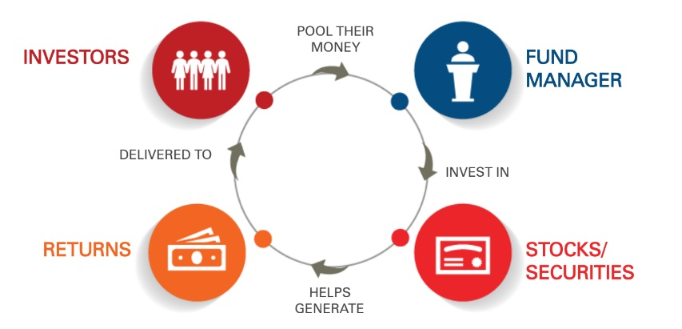

How to invest in MUTUAL FUND

- How do I apply for Investments in a fund?

Obtain an application form along with the Offer Document from your investment advisor / broker / agents, download it from our website or procure it from any of offices or investor service centers

- Read and understand the Offer Document and complete the application for

Attach a cheque for the amount you would like to invest. You can also transfer the money electronically if you have an account in bank.

The completed application can be mailed to or dropped off at any of AMC offices or investor service centers.

- Where do I get applications?

The applications can be obtained from CAMS, SERVICE CENTREs / Fund offices or branches. Alternatively, they can be downloaded from the Website of the funds houses.

- What documents do I need to submit with my initial application to buy units of mutual funds?

The following is a list of documents required by an investor while investing in mutual fund for the first time.

Subsequent investments do not need these documents.

Those who indicate "Individual" in the "Status" division of the application form

The application complete in all respects Those who indicate "Corporate" in the "Status" division of the application form

Certified copy of Memorandum of Association/ Articles of Association. Board Resolution authorizing the company to invest in mutual funds. List of authorized signatories with specimen signatures.

Those who indicate "Trust" in the "Status" division of the application form

Trust Deed.

List of authorized signatories with specimen signatures. Board Committee Resolution.

Those who indicate "Societies" in the "Status" division of the application form

Board Committee Resolution. Bylaws .

List of authorized signatories with specimen signatures

Those who indicate "Partnership Firms" in the "Status" division of the application form

Board Committee Resolution, Partnership Deed.

List of authorized signatories with specimen signatures

- Where do I submit my application form?

The Application can be mailed to or dropped off at any of offices of AMC or investor service centers.

- Are there any minimum amount limits for subsequent purchases in the same scheme?

Yes, limits of minimum amount are applicable for additional purchases for schemes and will be mentioned in the Offer Document.

- How can I transfer money between various schemes? Do loads Prevail?

Yes, you can switch between schemes/investment options/plans. You need to complete a transaction slip, which you can download from website or detach from the bottom of your account statement. A switch from one scheme to the other is treated as redemption from the scheme from where it is switched out & a purchase into the scheme into which it is being switched. Thus you will be liable for any 'applicable' entry load, exit load, or CDSC

- What is a lock-in period for my units?

Lock-in period is a time span during which the money invested cannot be redeemed. In the case of open-ended funds there are no lock in periods, however in the case of tax saving funds a minimum lock-in period of 3 years is applicable.

What is NAV ?

Net asset value is the value of an entity's assets minus the value of its liabilities, often in relation to open-end or mutual funds, since shares of such funds registered with the U.S. Securities and Exchange Commission are redeemed at their net asset value.

How to calculate NAV ?
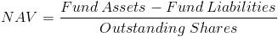

AMC – Asset management company

MF Forms submitted in RTA there are many RTA Karvy, Cams, Franklin, Sundram etc.

How to get ARN / EUIN code ?

AMFI exam and the exam conductor is NISM then Cams give a ARN number and for employee cams give a EUIN number .

- What is AMFI ?

The Association of Mutual Funds in India (AMFI) is an industry standards organisation in India in the mutual funds sector. It was formed in 1995. Mostmutual funds firms in India are its members. The organisation aims to develop themutual funds market in India, by improving ethical and professional standards.

- What is ARN & EUIN ?

AMFI, has allotted Employee Unique Identity Number (EUIN) to all the employees, who are registered with AMFI and having valid registration. A photo identity card bearing EUIN is also being issued to the existing corporate employees after they surrender existing corporate employee ARN card issued to them.

- What is CKYC ?

CKYC refers to Central KYC (Know Your Customer), an initiative of the Government of India. ... CKYC will be managed by CERSAI (Central Registry of Securitization Asset Reconstruction and Security Interest of India), which is authorized by Government of India to function as the CentralKYC Registry (CKYCR).

KYC DOCUMENTS – INDIVIDUALS

- ID Proof – PAN Card
- Address Proof – Addhar card
- One Photo

KYC DOCUMENTS – NON-INDIVIDUALS For HUF

- Non Individual PAN Card
- Address Proof – Bank Statement
- All Members Personal Documents
- PAN Card
- Addhar Card

KYC DOCUMENTS Partnership Firm

- Copy of Balance sheet for Last 2 Years
- Copy of Partnership Deed
- Authorised Signatories List
- Photographs of all Partners
- Address Proof of Partners and Company
- PAN Cards of Partners And Company

How to Check KYC ?

It is now very easy to check KYC your status online. You can go to the official website of CDSL Ventures Limited and enter in your PAN number to check if you are KYC compliant or not. If you are, there is no need to do it again.

